# Current transformer

A **current transformer** (**CT**) is used for measurement of alternating electric current. Current transformers, together with voltage (or potential) transformers (VT or PT), are known as **instrument transformers**. When current in a circuit is too high to apply directly to measuring instruments, a current transformer produces a reduced current accurately proportional to the current in the circuit, which can be conveniently connected to measuring and recording instruments. A current transformer isolates the measuring instruments from what may be very high voltage in the monitored circuit. Current transformers are commonly used in metering and [protective relays](https://en.wikipedia.org/wiki/Protective_relay) in the [electrical power industry](https://en.wikipedia.org/wiki/Electrical_power_industry).

Design

Like any other [transformer](https://en.wikipedia.org/wiki/Transformer), a current transformer has a primary winding, a [magnetic core](https://en.wikipedia.org/wiki/Magnetic_core) and a secondary winding. The [alternating current](https://en.wikipedia.org/wiki/Alternating_current) in the primary produces an alternating magnetic field in the core, which then induces an alternating current in the secondary winding circuit. An essential objective of current transformer design is to ensure the primary and secondary circuits are efficiently coupled, so the secondary current is linearly proportional to the primary current.

The most common design of CT consists of a length of wire wrapped many times around a silicon steel ring passed 'around' the circuit being measured. The CT's primary circuit therefore consists of a single 'turn' of conductor, with a secondary of many tens or hundreds of turns. The primary winding may be a permanent part of the current transformer, with a heavy copper bar to carry current through the magnetic core. Window-type current transformers (aka zero sequence current transformers, or ZSCT) are also common, which can have circuit cables run through the middle of an opening in the core to provide a single-turn primary winding. When conductors passing through a CT are not centered in the circular (or oval) opening, slight inaccuracies may occur.

Shapes and sizes can vary depending on the end user or switchgear manufacturer. Typical examples of low-voltage single ratio metering current transformers are either ring type or plastic molded case. High-voltage current transformers are mounted on porcelain or polymer insulators to isolate them from ground. Some CT configurations slip around the bushing of a high-voltage transformer or circuit breaker, which automatically centers the conductor inside the CT window.

Current transformers can be mounted on the low voltage or high voltage leads of a power transformer; sometimes a section of bus bar is arranged to be easily removed for exchange of current transformers.

## Usage

Current transformers are used extensively for measuring current and monitoring the operation of the [power grid](https://en.wikipedia.org/wiki/Power_grid). Along with voltage leads, revenue-grade CTs drive the electrical utility's watt-hour meter on virtually every building with three-phase service and single-phase services greater than 200 amperes.

The CT is typically described by its current ratio from primary to secondary. Often, multiple CTs are installed as a "stack" for various uses. For example, protection devices and revenue metering may use separate CTs to provide isolation between metering and protection circuits, and allows current transformers with different characteristics (accuracy, overload performance) to be used for the devices.

The primary circuit is largely unaffected by the insertion of the CT. The rated secondary current is commonly standardized at 1 or 5 amperes. For example, a 4000:5 CT secondary winding will supply an output current of 5 amperes when the primary winding current is 4000 amperes. The secondary winding can be single or multi-ratio, with five taps being common for multi-ratio CTs.

The load, or burden, of the CT should be a low resistance. If the voltage time integral area is higher than the core's design rating, the core goes into [saturation](https://en.wikipedia.org/wiki/Saturation_(magnetic)) toward the end of each cycle, distorting the waveform and affecting accuracy.

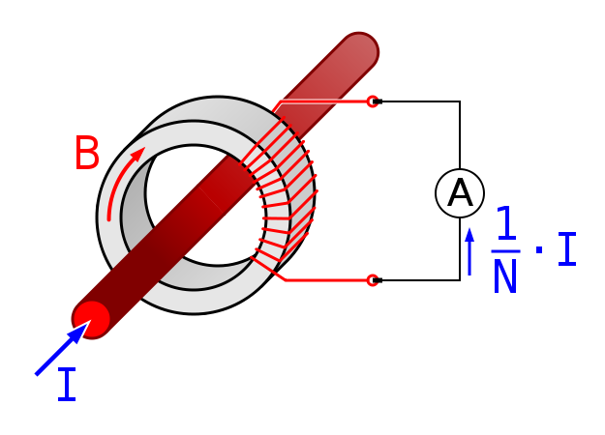

## Accuracy

The accuracy of a CT is directly related to a number of factors including:

* Burden
* Burden class/saturation class
* Rating factor
* Load
* External [electromagnetic fields](https://en.wikipedia.org/wiki/Electromagnetic_field)
* [Temperature](https://en.wikipedia.org/wiki/Temperature)
* Physical configuration
* The selected tap, for multi-ratio CTs
* Phase change

For the IEC standard, accuracy classes for various types of measurement are set out in IEC 61869-1, Classes 0.1, 0.2s, 0.2, 0.5, 0.5s, 1 and 3. The class designation is an approximate measure of the CT's accuracy. The ratio (primary to secondary current) error of a Class 1 CT is 1% at rated current; the ratio error of a Class 0.5 CT is 0.5% or less. Errors in phase are also important especially in power measuring circuits, and each class has an allowable maximum phase error for a specified load impedance.

Current transformers used for protective relaying also have accuracy requirements at overload currents in excess of the normal rating to ensure accurate performance of relays during system faults. A CT with a rating of 2.5L400 specifies with an output from its secondary winding of 20 times its rated secondary current (usually 5 A × 20 = 100 A) and 400 V (IZ drop) its output accuracy will be within 2.5 percent.