5V PCB Mounting Buzzer

This is a small PCB (printed circuit board) mountable buzzer. Its small size makes it perfect for all types of DIY and breadboard projects as well as actual electronics production.

This Buzzer module emit really loud sound when 3V to 5V is apply to it.  Unlike a plain piezo, this buzzer does not need an AC signal. Inside is a piezo plus the driver circuitry that makes it oscillate at 2 KHz. On one hand, that makes it really great for integrating into projects because you don’t need an oscillating control signal. but On the other hand, you cannot change the frequency.

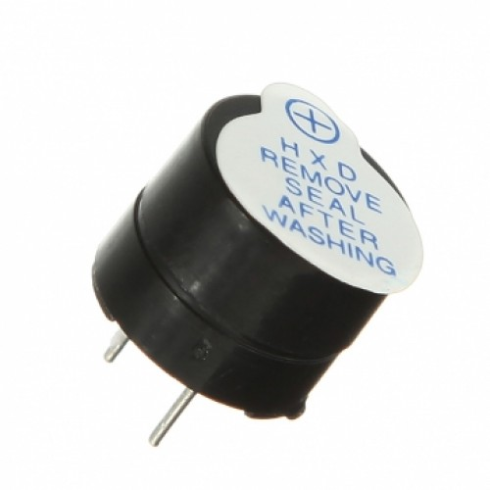Features of Buzzer

Tone Type: single

Operating Voltage: 4.5-5.5Vdc

Rated Voltage: 5V DC

Current Consumption: 50mA

Osc. Frequency: 2.3kHz±0.4

Sound Level: 85dB

Connector Type: PCB

Body Color: black

Weight: 3gm